CO1 – ASSESSMENT TOOL 2
QUERY PROCESSING FOR DATA SCIENCE

Student Name | SIDDARTH P
Reg Number | 192324264
SLOT | D
Questions Covered | Q33 - Weather Data Processing, Q34 - Online Shopping Orders
Tools Used | Python, Pandas
Date of Submission | 25 July 2026

Question 33 — Weather Data Processing
Question
Daily weather information is stored in weather.csv. The task is to find the highest and lowest recorded temperatures, calculate the average rainfall, identify the days where rainfall exceeded 100 mm, and export the filtered data to a new CSV file.

Approach
1. Load weather.csv into a Pandas DataFrame with columns Date, Temperature and Rainfall.
2. Use the max() and min() functions on the Temperature column to get the highest and lowest temperature values.
3. Use the mean() function on the Rainfall column to compute the average rainfall, rounded to two decimals.
4. Filter the DataFrame using a boolean condition (Rainfall > 100) to identify heavy rainfall days.
5. Export the filtered rows to heavy_rainfall_days.csv using to_csv().

Code
import pandas as pd

df = pd.read_csv("weather.csv")

highest_temp = df["Temperature"].max()
lowest_temp = df["Temperature"].min()
avg_rainfall = df["Rainfall"].mean()

print("Highest Temperature:", highest_temp)
print("Lowest Temperature:", lowest_temp)
print("Average Rainfall:", round(avg_rainfall, 2))

heavy_rain = df[df["Rainfall"] > 100]
print("\nDays with Rainfall above 100 mm:")
print(heavy_rain)

heavy_rain.to_csv("heavy_rainfall_days.csv", index=False)
print("\nFiltered data exported to heavy_rainfall_days.csv")

Output
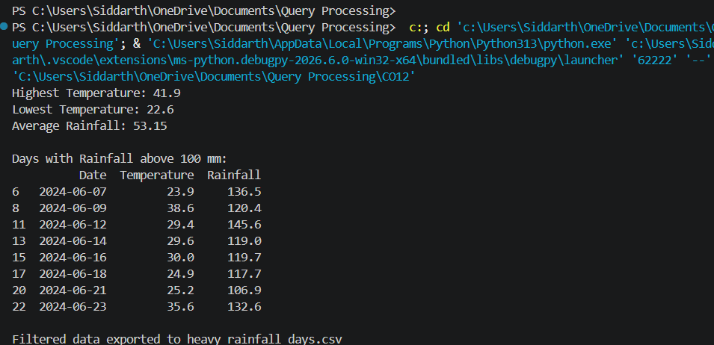

Question 34 — Online Shopping Orders
Question
Order details are stored in orders.csv. The task is to identify duplicate Order IDs, remove the duplicate records, calculate the total order value, display the customer with the highest purchase amount, and save the updated dataset.
Approach
1. Load orders.csv into a Pandas DataFrame with columns OrderID, Customer, Product, Quantity and Price.
2. Use duplicated() on the OrderID column with keep=False to display every duplicate record.
3. Use drop_duplicates() with keep='first' to remove repeated OrderID entries.
4. Create a new OrderValue column as Quantity multiplied by Price, then sum it for the total order value.
5. Group the data by Customer, sum OrderValue per customer, and use idxmax() to find the top customer.
6. Save the cleaned dataset to orders_cleaned.csv using to_csv().
Code
import pandas as pd

df = pd.read_csv("orders.csv")

duplicate_ids = df[df.duplicated("OrderID")]
print("Duplicate Order IDs found:")
print(duplicate_ids)

df = df.drop_duplicates("OrderID")
print("\nRecords after removing duplicates:", len(df))

df["OrderValue"] = df["Quantity"] * df["Price"]
total_value = df["OrderValue"].sum()
print("\nTotal Order Value:", total_value)

top_customer = df.groupby("Customer")["OrderValue"].sum().idxmax()
top_amount = df.groupby("Customer")["OrderValue"].sum().max()
print("Customer with Highest Purchase Amount:", top_customer, "-", top_amount)

df.to_csv("orders_cleaned.csv", index=False)
print("\nUpdated dataset saved to orders_cleaned.csv")

Output
